Regularization in Machine Learning

1️⃣ Why do we need regularization?
When we fit a regression model:
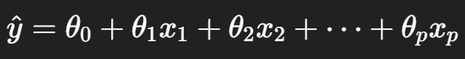
- If p (number of features) is large, or features are correlated,
- The model may overfit → fits training data too well, but generalizes poorly.
- Overfitting usually shows as:
  - Low training error
  - High test error
👉 Regularization = technique to control model complexity by penalizing large parameter values.

2️⃣ The General Idea
We modify the cost function by adding a penalty term on parameters:
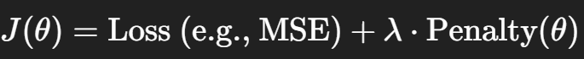Where:
- λ = regularization parameter (controls strength of penalty).
- Penalty discourages large coefficients → prevents model from relying too heavily on any one feature.

3️⃣ Types of Regularization
🔹 a. Ridge Regression (L2 Regularization)
Cost function:
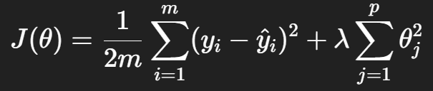​
- Adds sum of squares of weights.
- Shrinks coefficients smoothly toward zero (but not exactly zero).
- Keeps all features, but with smaller weights.
- Good when many correlated features.
📌 Analogy: coefficients pulled toward origin by a “rubber band”.

🔹 b. Lasso Regression (L1 Regularization)
Cost function:
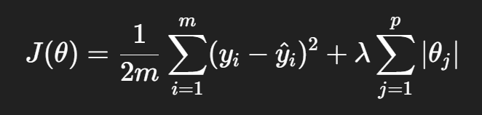
- Adds sum of absolute values of weights.
- Forces some coefficients exactly to zero → automatic feature selection.
- Good when we expect only a few features to matter.
📌 Analogy: coefficients stick to the axis due to "taxicab geometry".

🔹 c. Elastic Net (Combination of L1 + L2)
Cost function:
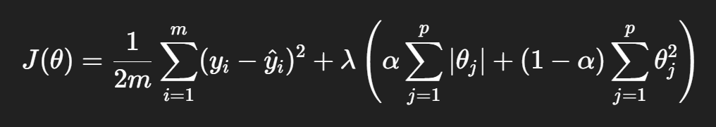
- Mix of Ridge + Lasso.
- Useful when:
  - Many features are correlated (Ridge effect).
  - Some features are irrelevant (Lasso effect).

